# 

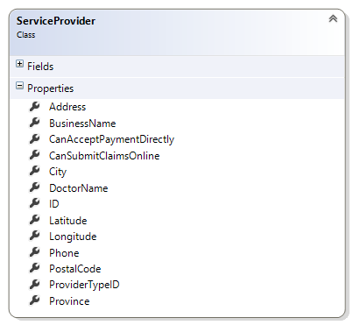

# Properties

LocationTypes(List<SearchLocationType>)

SelectedLocationType (SearchLocationType)

SearchTypes(List<SearchType>)

SelectedSearchType (SearchType)

SearchRadius (int)

Address (string) -> May need a formatter in the setter to make sure Address doesn’t have padding spaces, or other artifacts that may bork the back-end search

PostalCode (string) -> May need a formatter in the setter to make sure Postal Code complies with back-end search

PhoneNumber (string) -> may need a formatter in the setter

LastName(string)

BusinessName(string)

City(string)

ProviderType -> passed in by the previous viewmodel. A helper to remind the viewmodel what service provider type is being sought.

Show* Properties -> Visibility Helpers indicating which set of controls to display on the screen. For instance “ShowSearchTypeLastName” should result in a label/textbox combination being displayed to allow the user to enter the Last Name to search for. The LastName property should be bound to this textbox

# Commands

FindProviderCommand. No Parameters -> executes the back end request and navigates to a new viewmodel to display the list of results

Alternate Flow -> May instead raise a NoProvidersFound event

# Events

NoProvidersFound